Grid Antenna Test 07/09/2019

Equipment:

- PaccL #1 – IP: 192.168.88.100
- PaccL #2 – IP: 192.168.88.101
- 2 Laptops
- 2 Grid Antennas

Setup:

PaccL #1 was setup (as the server) and wired to a grid antenna just outside the highbay garage. PaccL #2 was setup (as the client) and wired to a grid antenna in front of the dumpsters. The distance between the antennas was approximately 400 ft. Both PaccLs were set to 4.95 GHz with a bandwidth of 20 MHz.

Conducted Tests:

- Ping test – PaccL #1 alone, PaccL #2 alone, PaccL #1 and #2 simultaneously.
- TCP iperf test – PaccL #1 alone, PaccL #2 alone, PaccL #1 and #2 simultaneously.
- UDP iperf test – PaccL #1 alone, PaccL #2 alone, PaccL #1 and #2 simultaneously.

Ping Test:

 | Min (ms) | Ave (ms) | Max (ms) | Mdev (ms)
PaccL #1 alone | 0.695 | 4.538 | 32.874 | 7.226
PaccL #2 alone | 0.703 | 4.930 | 35.050 | 7.786
PaccL #1 simultaneous | 0.698 | 1.667 | 18.335 | 2.816
PaccL #2 simultaneous | 0.816 | 2.203 | 27.371 | 4.241

For the simultaneous test, there was 8% loss. All other tests had a 0% loss.

TCP Iperf Test:
 | Transfer (Mbytes) | Bandwidth (Mbits/s) | Send/Recieve
PaccL #1 alone | 125 | 17.5 | sender
 | 125 | 17.4 | receiver
PaccL #2 alone | 91.8 | 12.8 | sender
 | 91.6 | 12.8 | receiver
PaccL #1 simultaneous | 61.2 | 8.56 | sender
 | 60.5 | 8.40 | receiver
PaccL #2 simultaneous | 29.3 | 4.09 | sender
 | 28.8 | 4.03 | receiver

UDP Iperf Test:

 | Transfer (Mbytes) | Bandwidth (Mbits/s) | Jitter (ms) | Loss/Total Datagrams
PaccL #1 alone | 7.49 | 1.05 | 2.354 | 0/959 – 0%
PaccL #2 alone | 7.49 | 1.05 | 3.916 | 1/959 – 0.1%
PaccL #1 simultaneous | 7.49 | 1.05 | 5.420 | 0/959 – 0%
PaccL #2 simultaneous | 7.49 | 1.05 | 8.250 | 7/959 – 0.73%

PaccL Firmware:
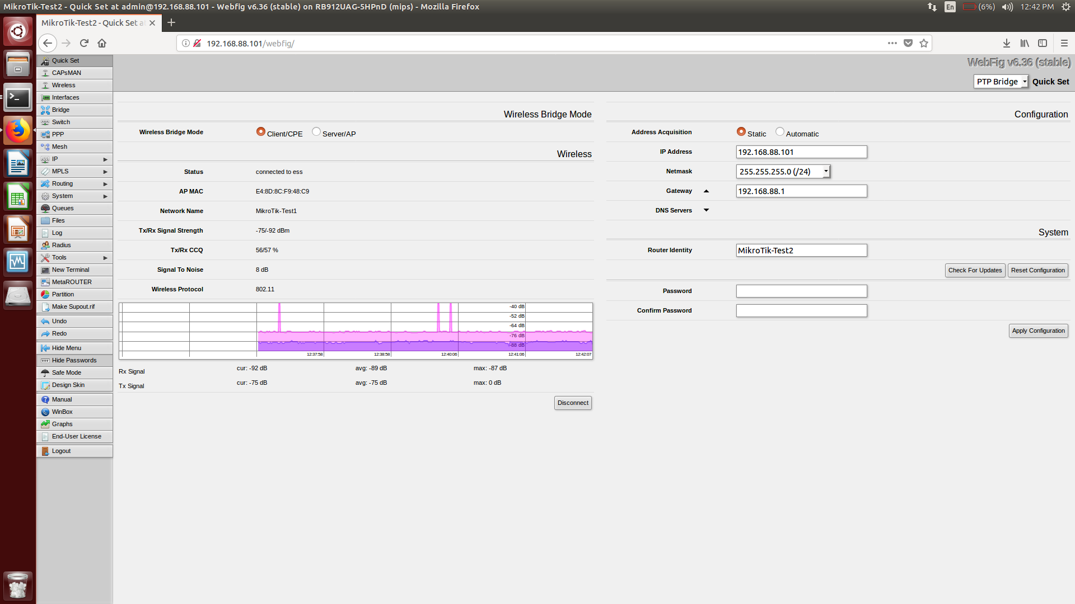
Info on PaccL #1 and #2:
- Channel power TX: -75 dBm
- Channel power RX: -89 dBm
- Signal to noise: 8 dBm

